**IT5016: Software Development Fundamentals**

**Assessment 1: Flow chart and pseudo-code**

Student Name: Prem Jayeshkumar Patel

Student ID : 20240334

Flowchart:

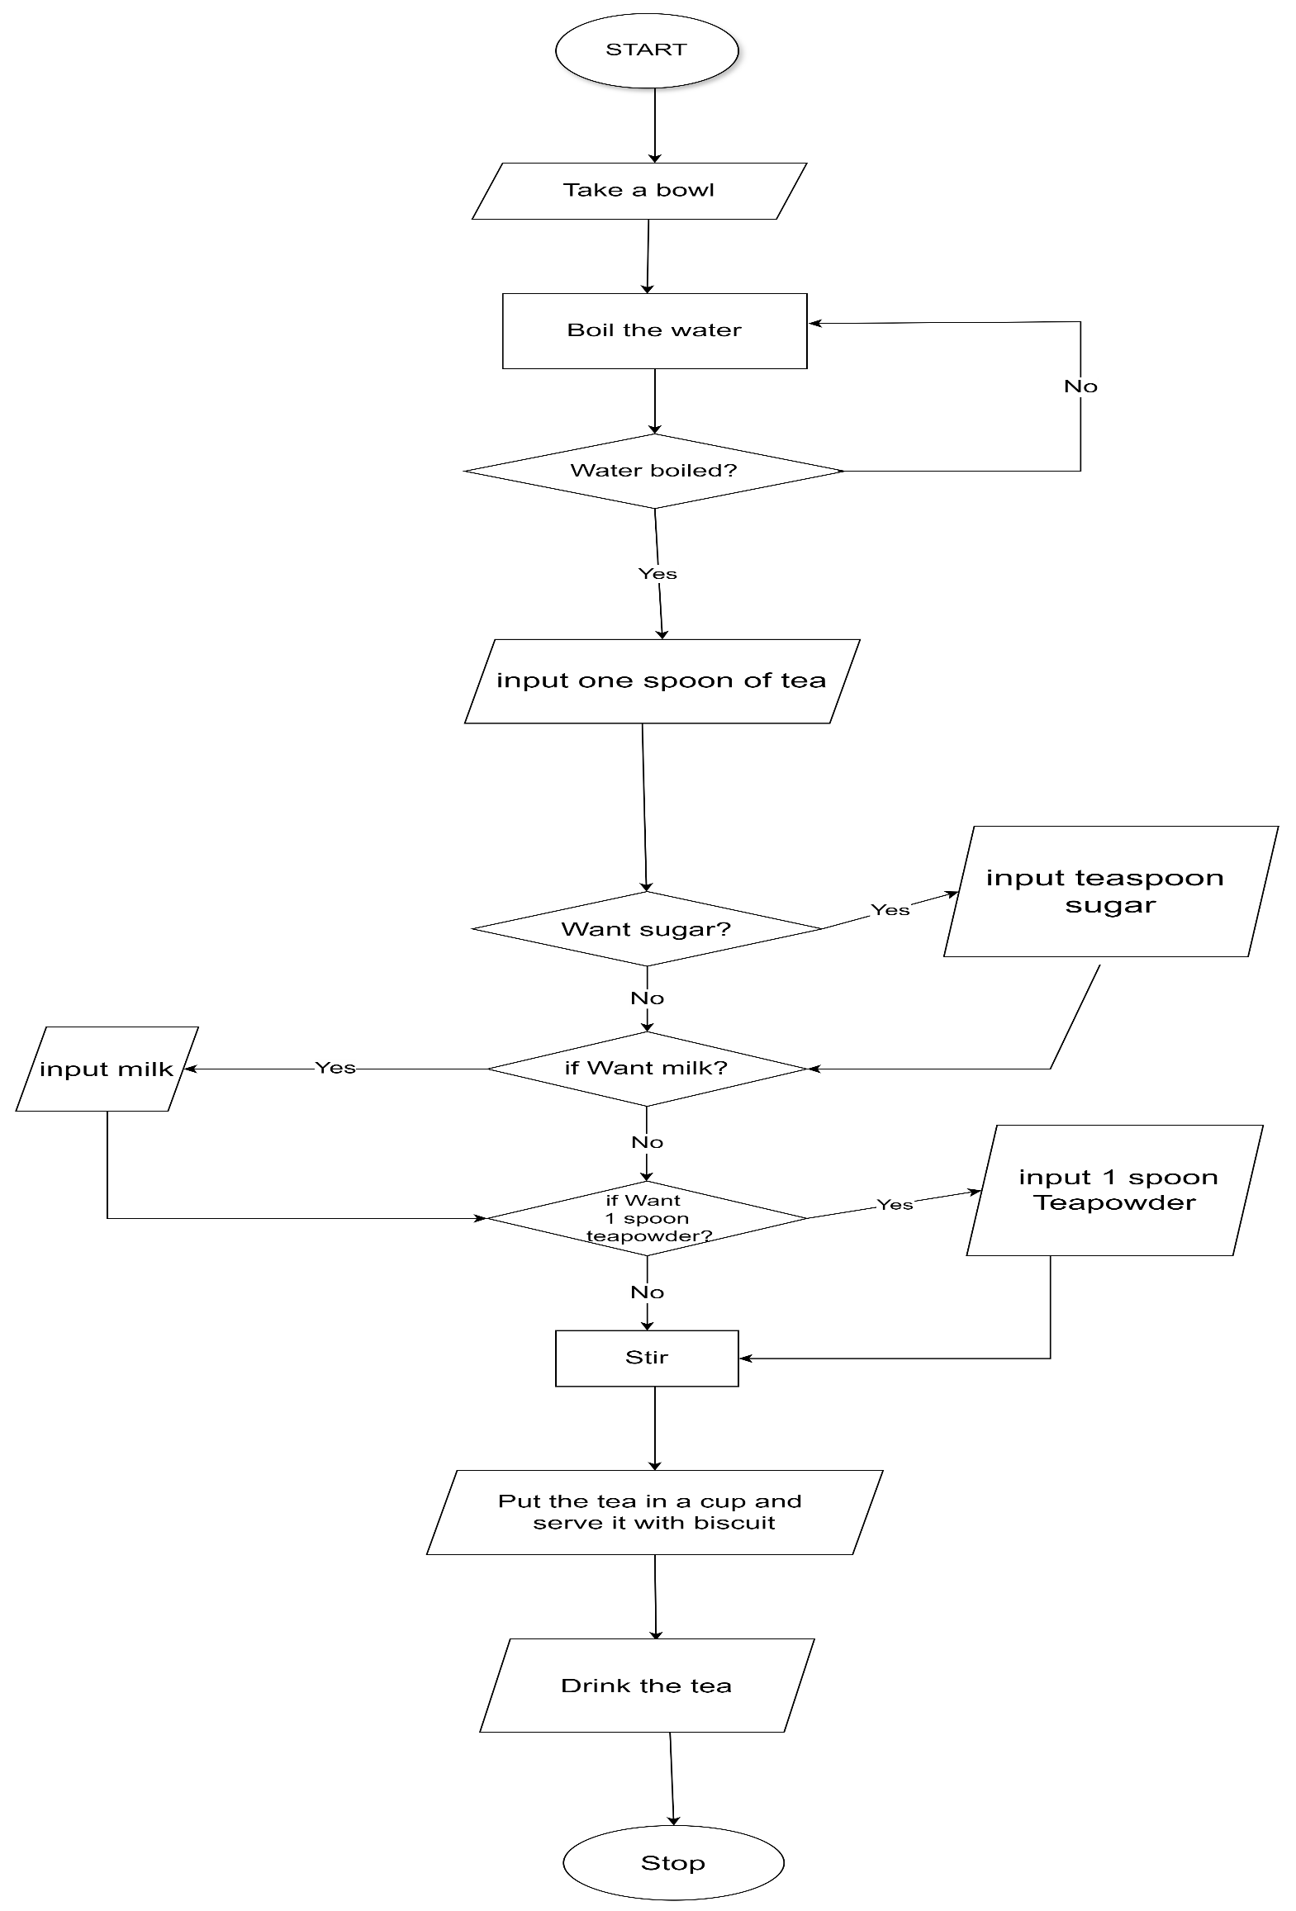

Pseudocode:

Start

    Input Bowl

    Boilwater for 5 min

  if Water is Completely boiled

    Input One spoon Tea

  else :

    continue boiling Process

    Input Tea in to the boiled water

    if want sugar then

      input sugar

    elif you want milk then

      input milk

    elif you want  1 spoon teapowder

      input 1 teaspoon powder

    else :

      mix the tea

      output : rea in to the cup

      serve it with biscuit

End